Simeon Patton

CS362 – OSU Spring 2021

Homework 7 – Test first development

GitHub repo for files and programs can be found at:

<https://github.com/pattons-OSU/CS362_Homework/tree/master/Week_9>

Question 1;

1. test_fizzbuzz.py and fizzbuzz.py

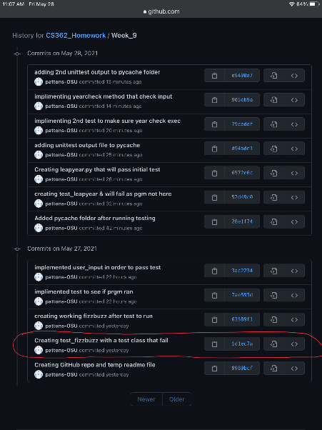

First, I created the test file and implemented the first test that would fail because the actual running program did not exist.

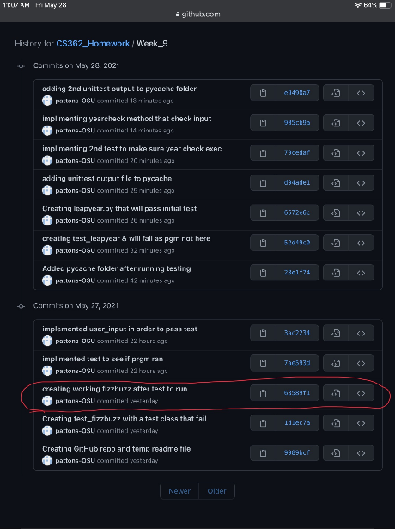

Next, I created the actual running program with one method that was intended to pass the initial unittest module.

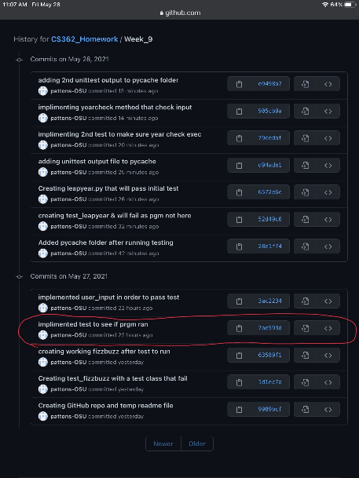

A Second test module was created without the implimitation of coresponding code in order to demonstrate test-driven development.

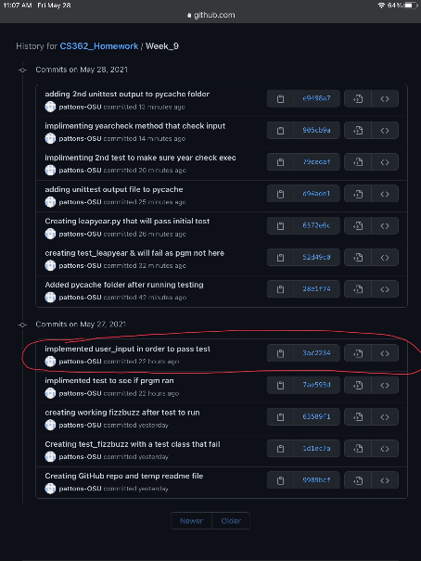

Last, another method was created within the running program in order to make the created test pass.

Question 2;

1. test_leapyear.py and leapyear.py

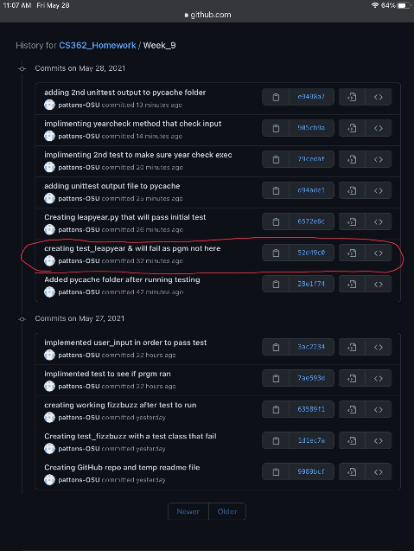

First, I created the test file and implemented the first test that would fail because the actual running program did not exist.

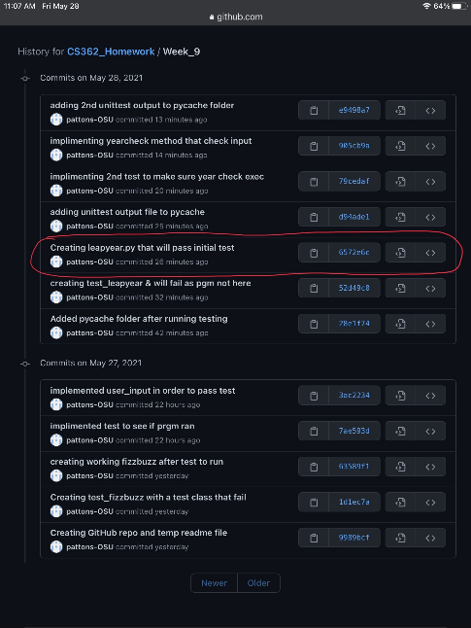

Next, I created the actual running program with one method that was intended to pass the initial unittest module.

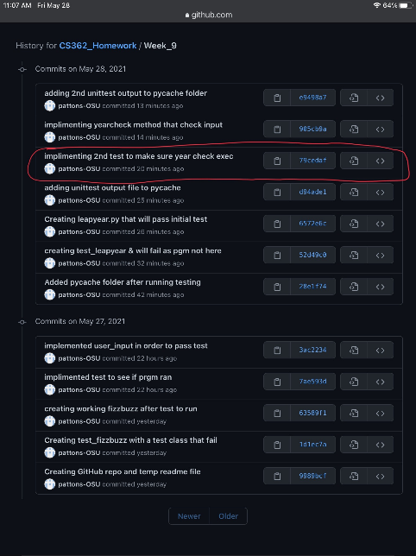

A Second test module was created without the implimitation of coresponding code in order to demonstrate test-driven development.

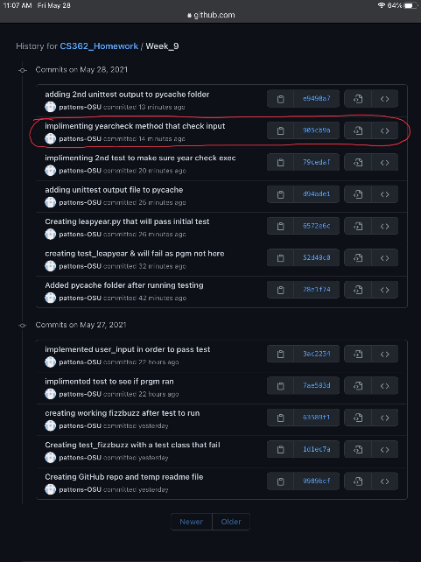

Last, another method was created within the running program in order to make the created test pass.

Question 3;

1. For the social media application, I chose to showcase Facebook. Within Facebook, I will be looking at the peer-to-peer messaging system. In order to create this system with a test-driven development style I would:
   1. Create a test that provides an error when the message or subject is empty.
   2. Create code that checks to see if the input boxes and spaces are void of ANY datatype.
   3. Create code that would supply some predetermined “quick reply” messages if the user does not want to fill in the boxes.
   4. Create a test that verifies that the message is going to a specific user and confirms receipt.
   5. Create code that packages and delivers the message to the intended recipient.
   6. Create code that provides the original sender with a delivery receipt once the message has been confirmed to be delivered to the correct user.